To print an official transcript, you must perform two steps.
- Request the official transcript
- Print the official transcript
Use this reference to complete the steps required to print an official transcript.

Step 1 - Request the Official Transcript
- In the search bar, look up the Request Official Transcripts for Students task.

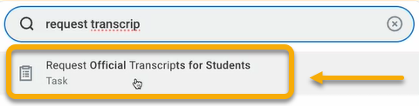

- The Request Official Transcripts for Students page will open.

Select Student
- To select a student, locate the Student field and enter the student’s name. After entering, additional fields may appear.
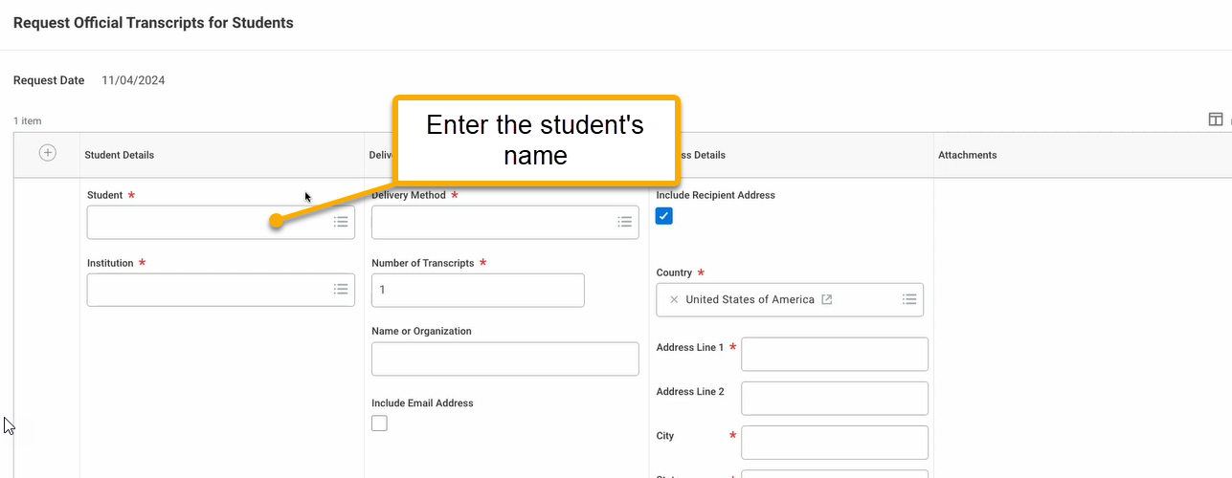

Select Academic Record(s)
- Locate and click the Transcript Records field. All academic records associated with the student will appear. Select the academic records you wish to be included in the official transcript.

TIP: If more than one academic record is selected, all academic information is merged into a single transcript.

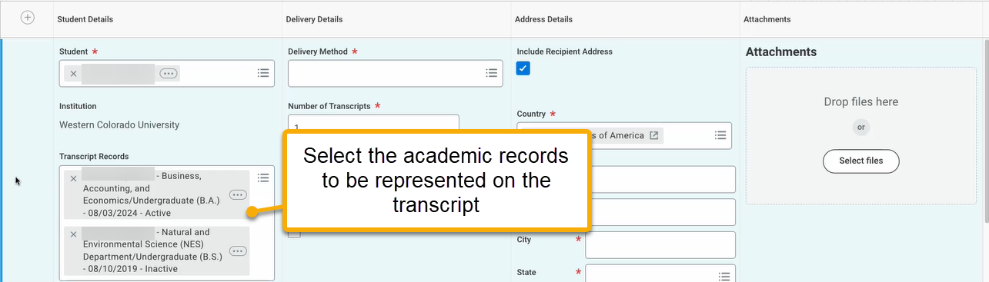

Set Delivery Options
- Locate and click the Delivery Method field. For the purposes of printing, you can select any value.

- Uncheck the “Include Recipient Address” checkbox.

- You have the option to add an attachment, such as a cover letter. To do so, click “Select Files”.
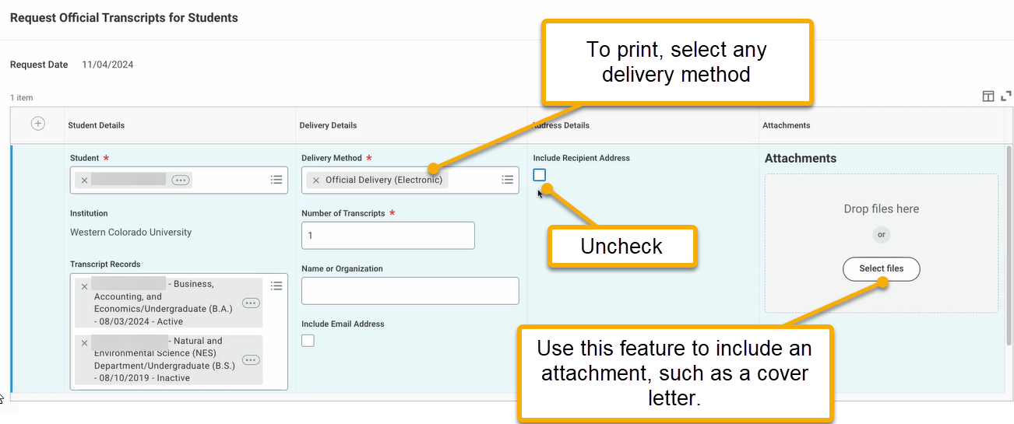
Create Additional Requests (as needed)
- To request another official transcript for an additional student, click the plus sign in the top left-hand corner and complete the fields.
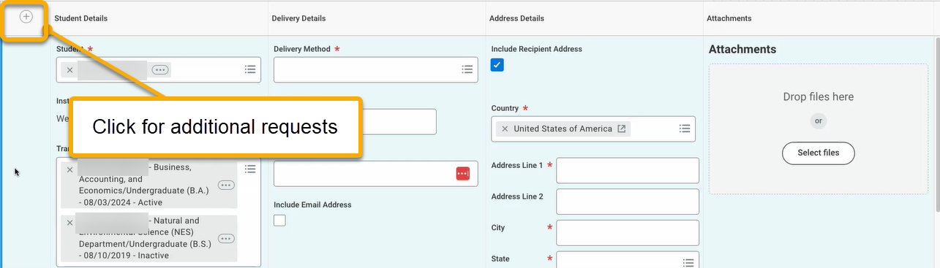
- When finished, click “OK”.

Step 2 - Print the Official Transcript
- In the search bar, look up the Print Official Transcripts task.
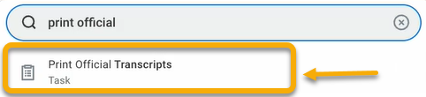
- The Print Official Transcripts window will appear with default values in the required fields. Leave as is.
Click “OK”.
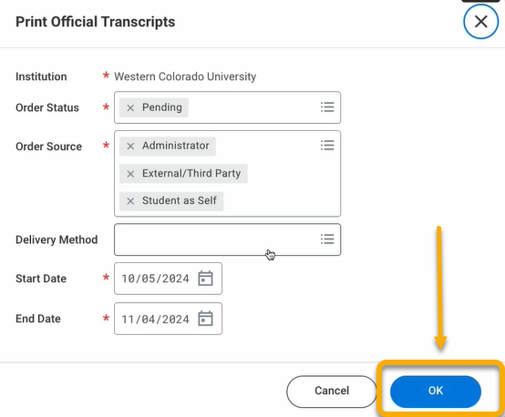
- The Print Official Transcripts page will appear. Select the student transcripts that you wish to print.

Click “Generate Transcript”.

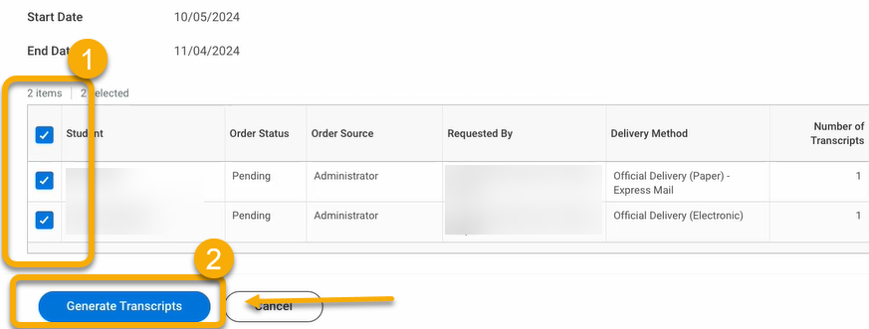

- On the next page, click the “Refresh” button repeatedly until the documents reach 100% complete.
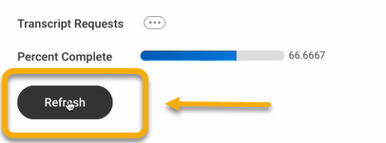
- At completion, the transcripts will be available for download as PDF files.
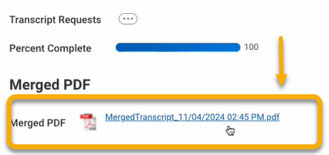
- Click to open and review.

You will notice the transcripts of both students are delivered as one file. You may need to split the pdf file as needed.

